matlab编译生成的控制台程序，改成win32程序
1．将生成的main函数改成如下
int __stdcall WinMain(
HINSTANCE hInstance,
HINSTANCE hPrevInstance,
LPSTR lpCmdLine,
int nShowCmd
)
{
if (!mclInitializeApplication(
__MCC_（文件名）_component_data.runtime_options,
__MCC_（文件名）_component_data.runtime_option_count))
return 0;

return mclRunMain(run_main,1,&lpCmdLine);
}

2．将生成的run_main函数改成
int run_main(int argc, const char **argv)
{
int _retval;
/* Generate and populate the path_to_component. */
char path_to_component[(PATH_MAX*2)+1];
separatePathName(argv[0], path_to_component, (PATH_MAX*2)+1);
__MCC_ddqre_component_data.path_to_component = path_to_component;
__MCC_ddqre_component_data.path_to_component = ".\\";(本句是自己增加的)
if (!ddqreInitialize()) {
return -1;
}
_retval = mclMain(_mcr_inst, argc, argv, "ddqre", 1);
if (_retval == 0 /* no error */) mclWaitForFiguresToDie(NULL);
ddqreTerminate();
mclTerminateApplication();
return _retval;
}
（注意：int main()和run_main()均在文件，文件名_main.c文件中）

3．在project|setting中通过link加入

libemlrt.lib libmex.lib libut.lib mclmcrrt.lib libeng.lib libmwlapack.lib mclcom.lib mclxlmain.lib libfixedpoint.lib libmwservices.lib mclcommain.lib libdflapack.lib libmat.lib libmx.lib mclmcr.lib 注意：一定写入附加库路径。

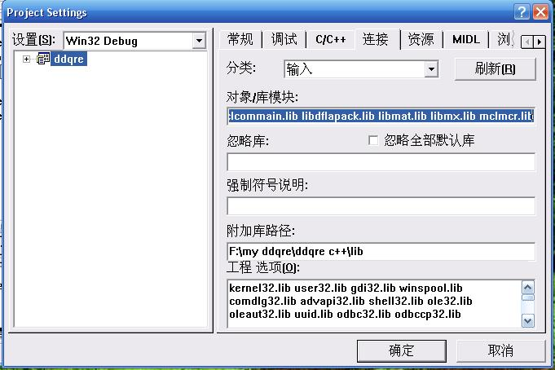

4．在c++的预编译头文件中自动应用stdafx.h

